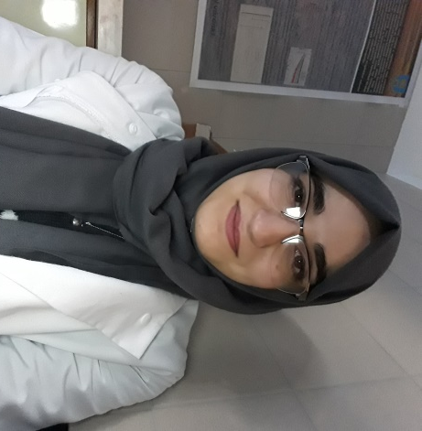
Name:
Mersel Maali-Amel

Research Group:
Environmental Photochemistry Research Group

Research Centre:
N/A

Department/School(s):
Doctoral School of Chemistry and Environmental Sciences

College:
University of Pannonia – Veszprém – Hungary

Supervisor(s):
Prof. Dr. Ottó Horváth and Dr. Fodor Lajos

Funding body:
Széchenyi 2020 under the GINOP-2.3.2-15-2016-00016 and the EFOP-3.6.1-16-2016-00015

Area (field) of study:
Photocatalytic Hydrogen production on metal modified ZnS-CdS semiconductors

Thesis Title:
Preparation and application of catalysts for photoelectrochemical conversion and storage of solar energy

Abstract:
Photocatalytic H₂S decomposition for hydrogen production is regarded to be an environmentally friendly process to produce a carbon-free energy in the future through direct solar energy conversion. Sulfide-based materials, as photocatalysts, are considered to be good candidates for hydrogen evolution due to their excellent solar spectrum responses and high photocatalytic activity. The loading of proper co-catalysts that are based on cheap and earth-abundant materials on those semiconductors, for cost effective solar to hydrogen conversion, was shown to play an important role in the improvement of their efficiency. In our research, we focused on the use of ZnS-CdS composite because of its controllable band gap width and excellent performance for hydrogen evolution under visible light irradiation. The effects of the modification of this photocatalysts with different types of materials on their hydrogen production activity were investigated.
The ZnS-CdS composite with an enhanced photocatalytic activity for H₂ production was synthesized. Two types of modification were used: compounds of Ni-group metals (NiS, PdS, and Pt) were applied as co-catalyst on the surface of ZnS-CdS semiconductor, while NiS, CuS, Ga₂S₃ and In₂S₃ were used as dopant in the bulk of the catalyst.

Collaborations:
N/A

Publications:
N/A

Presentations:
Central European Conference on Photochemistry (CECP 2020). Bad Hofgastein – Austria, 9-13 January 2020

